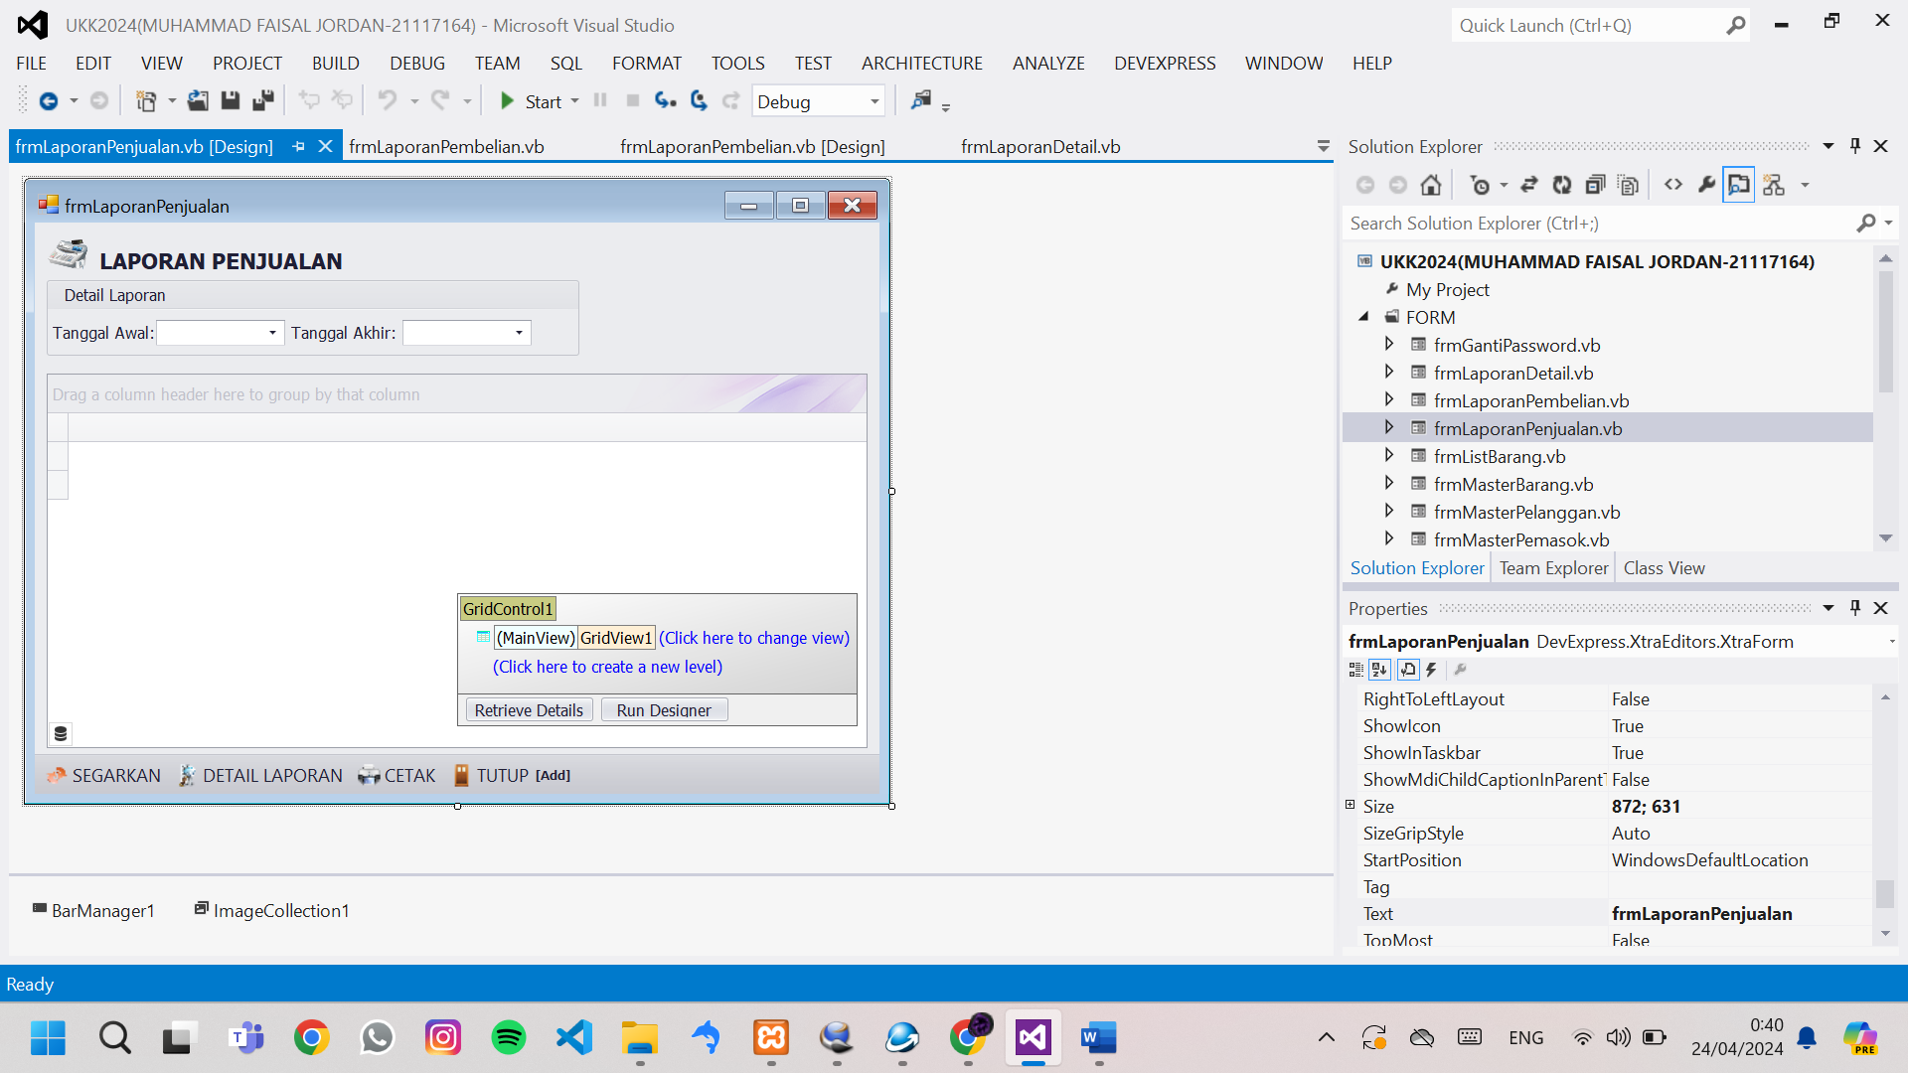

Public Class frmLaporanPenjualan

Dim Tampung As New DataTable

Public NilaiKiriman As Integer

Sub TampilTable()

Tampung = EksekusiSQL("select TANGGAL,ID_PENJUALAN,penjualan.ID_PELANGGAN,NAMA_PELANGGAN,TOTAL_PENJUALAN,POTONGAN,METODE_PEMBAYARAN,KETERANGAN,penjualan.ID_PENGGUNA,NAMA_PENGGUNA from penjualan, pelanggan, pengguna where penjualan.ID_PELANGGAN=pelanggan.ID_PELANGGAN and penjualan.ID_PENGGUNA=pengguna.ID_PENGGUNA and TANGGAL between '" & Format(txtTanggalAwal.DateTime, "yyyy-MM-dd") & "' and '" & Format(txtTanggalAkhir.DateTime, "yyyy-MM-dd") & "'")

GridControl1.DataSource = Tampung

'disini masih banyak pengaturan

'memberikan format pada kolom total_penjualan numrick currency

GridView1.Columns("TOTAL_PENJUALAN").DisplayFormat.FormatType = DevExpress.Utils.FormatType.Numeric

GridView1.Columns("TOTAL_PENJUALAN").DisplayFormat.FormatString = "c0"

'memberikan total pada kolom total_penjualan dan format berupa numric currency

GridView1.Columns("TOTAL_PENJUALAN").SummaryItem.SetSummary(DevExpress.Data.SummaryItemType.Sum, "{0:c0}")

GridView1.BestFitColumns()

End Sub

Sub DetailLaporan()

'memanggil frmlaporandetil

'cek dlu isi tabel

If GridView1.RowCount > 0 Then

frmLaporanDetail.NilaiKiriman = 2

frmLaporanDetail.ID = GridView1.GetFocusedRowCellValue("ID_PENJUALAN")

frmLaporanDetail.WindowState = FormWindowState.Maximized

frmLaporanDetail.ShowDialog()

End If

End Sub

Sub Cetak()

GridView1.OptionsPrint.PrintFilterInfo = True

GridView1.OptionsPrint.RtfReportHeader = "LAPORAN PENJUALAN" & vbCrLf & "PERIODE" & Format(txtTanggalAwal.DateTime, "dd MMMM yyyy") & " S/D " & Format(txtTanggalAkhir.DateTime, "dd MMMM yyyy") & vbCrLf

TTD(GridView1)

ExecuteGridControlPreview(GridControl1, GridControl1.LookAndFeel, True, Printing.PaperKind.A4, 15, 15, 15, 15)

End Sub

Sub Tutup()

Me.Close()

End Sub

Private Sub frmLaporanPembelian_KeyDown(sender As Object, e As KeyEventArgs) Handles Me.KeyDown

Select Case e.KeyCode

Case Keys.F5

TampilTable()

Case Keys.F1

DetailLaporan()

Case e.Control And Keys.P

Cetak()

Case Keys.Escape

Tutup()

End Select

End Sub

Private Sub frmLaporanPembelian_Load(sender As Object, e As EventArgs) Handles MyBase.Load

Me.KeyPreview = True

EksekusiRapikanGridView(GridView1)

GridView1.OptionsView.ShowFooter = True

'menampilkan tanggal hari ke tanggal awal dan tanggal akhir

txtTanggalAwal.DateTime = Now

txtTanggalAkhir.DateTime = Now

TampilTable()

End Sub

Private Sub GridView1_DoubleClick(sender As Object, e As EventArgs) Handles GridView1.DoubleClick

DetailLaporan()

End Sub

Private Sub BarButtonItem3_ItemClick(sender As Object, e As DevExpress.XtraBars.ItemClickEventArgs) Handles BarButtonItem3.ItemClick

TampilTable()

End Sub

Private Sub BarButtonItem5_ItemClick(sender As Object, e As DevExpress.XtraBars.ItemClickEventArgs) Handles BarButtonItem5.ItemClick

DetailLaporan()

End Sub

Private Sub BarButtonItem6_ItemClick(sender As Object, e As DevExpress.XtraBars.ItemClickEventArgs) Handles BarButtonItem6.ItemClick

Cetak()

End Sub

Private Sub BarButtonItem7_ItemClick(sender As Object, e As DevExpress.XtraBars.ItemClickEventArgs) Handles BarButtonItem7.ItemClick

Tutup()

End Sub

End Class